1. **Understanding the OPEN AI platform**
2. **Explore the OpenAI platform**

* Open AI – Ai research Development Company – goal to promote and develop friendly AI.
* Chat GPT creators
* Open AI developed multiple large language models or LLMs
* LLMs- Machine learning models that trained on massive amounts of data text data from a vide variety of sources.
* Different between ChatGPT and GPT?
* Chat GPT is a intelligence Chabot powered by GPT.

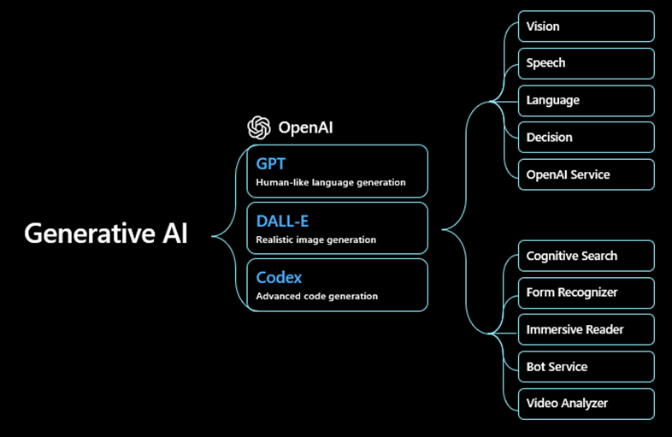

* Other models that open AI proved - DALL-E (create images and art from simple text description.)
* Whisper – Translate audio to text and translate languages.

Open AI API – provide the access to developers.

1. **Understand Generative AI models –**

* Generative AI models are like developers.
* They use learning patterns from data they are trained on create new things like music images, text etc.
* LLMs like Open AI GPT faily model user generative AI.

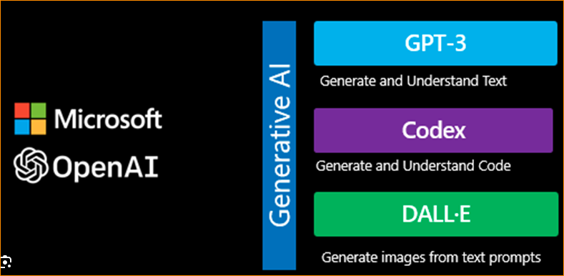

Because they are used to learning something new, like the next word or sentence base on the previous word.

LLMs has two types –

* GPT – Foundation model
* ChatGPT – Fine-tuned model.

Chat GPT is a fine-tuned model from the foundation model in a GPT 3.5 Family.

How foundation model train -

Generative Tasks

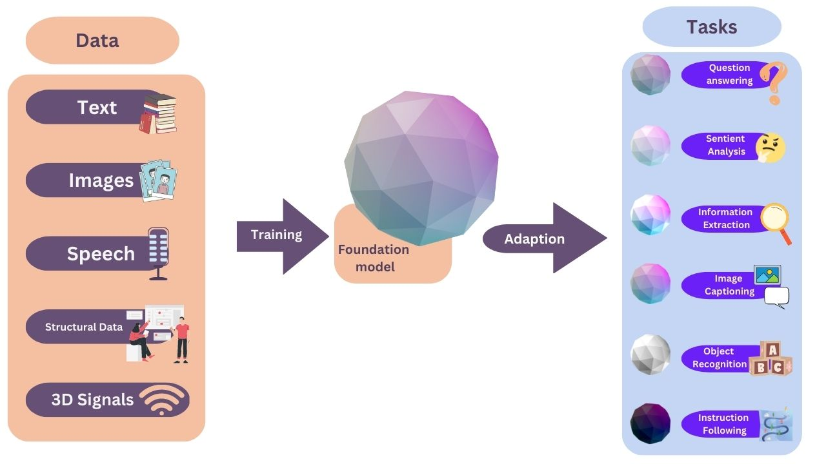

Use the large amounts of unlabeled data,

Like a massive collection of text data, web pages books and other sources to perform a wide variety of natural language processing (NLP), tasks.

The foundation model generalizes well to many generative tasks.

LLMs are trained to process natural language data using the transformer architecture.

That type of neural network learns to transform input sequences into output sequences.

GTP – Generative Pre-trained Transformer.

There are several types –

* GPT-3 – set of models that can understand and generate natural language.
* Text-davinci-003
* Text-curie-001
* Text-babbage-001
* Text-ada-001

GPT-3.5 is a Set of models that improve on GPT-3 and generate natural language or code.

GPT-4 is a improvement of 3.5

Chat GPT is fine-tuned from a model in the GPT-3.5 series using reinforcement learning from human feedback or RLHF.

1. **Assess model using the OpenAI API**

Open AI API – integrating system, developers can add any application by making API call to access LLMs created by OpenAI.

* 1st step – Authenticate the API using API key
* 2nd Step – Making a request to a specific model like GPT-3.5

Using prompt like ***“Which olive oil is best for cooking?”***

There is an attempt to match the input pattern you provided to an output value using tokenization.

* The GPT family of models processes text using tokens, which are common sequence of characters found in text.

For Example – “Token” + “ization” = Two tokens

While a short and common word like “The” is represent as a single token.

When the model returns response or completion, it is actually predicting the next token, not the next word.

In our Example prompt – <https://platform.openai.com/tokenizer>

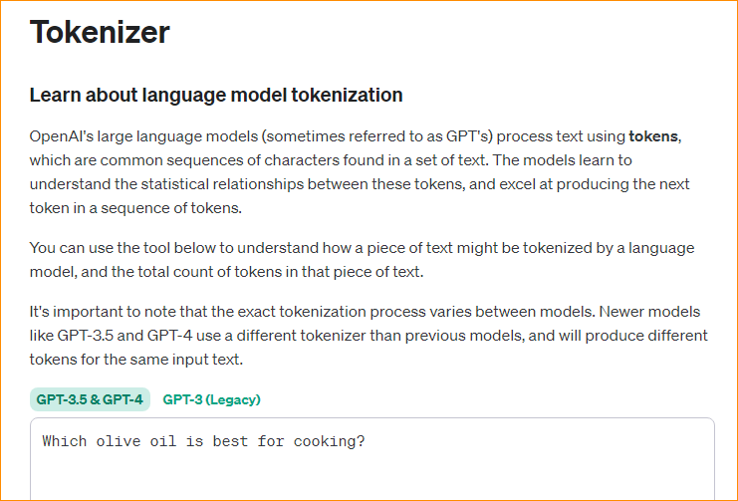

There are 8 tokens-

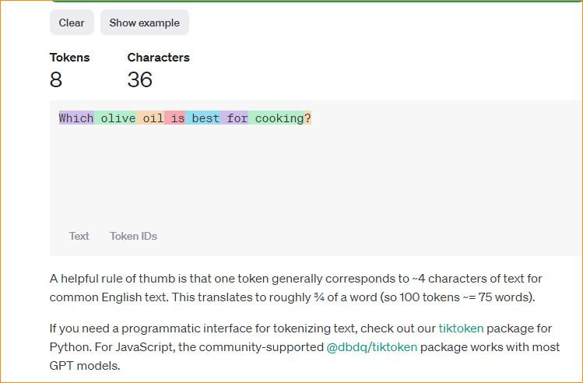

OpenAI provide this tool to help count tokens. Better understand how a piece of text would be tokenized by the API and the total count of tokens.

In here rate limitations places on the API calls and cost associated with using the OpenAI API.

The calls to the APIs are limited using the TPM, or Token per minute, which differs based on the model.

You are also build per token when using the API.

Gpt-3.5-turbo costs $0.002 per 1000 tokens.

<https://platform.openai.com/account/limits>

<https://platform.openai.com/playground?mode=chat>

Build on number of tokens sent in your prompt, plus the number of tokens in the completions returned by the API.

* Using OpenAI python Library to access the API endpoints programmatically. From our application code.